# Setup steps

Prerequisites

1. Visual Studio 2019
2. .net core 3.1
3. Sql server

Steps:

1. Create Database on server (localdb)\mssqllocaldb;

Database name: OnlineMessagingSystem

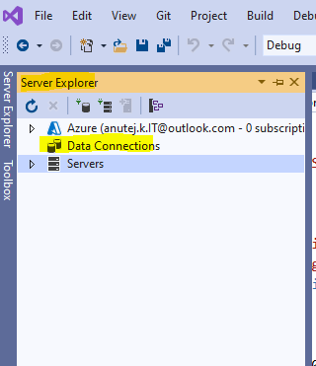

Right click on Data connections

Click on Create new sql server database

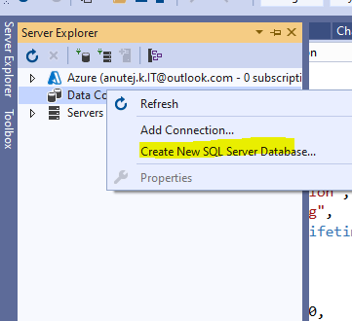

Enter details as below

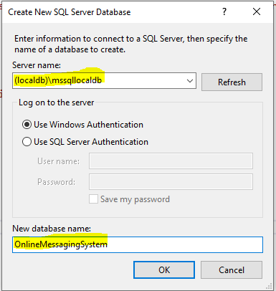

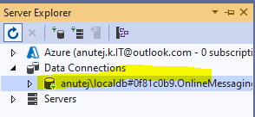

1. Download or clone the repository from git

<https://github.com/anutej423/ROPTIA-ANUTEJ-CHAT-CHALLENGE.git>

<https://github.com/anutej423/ROPTIA-ANUTEJ-CHAT-CHALLENGE/>

1. Compile the solution
2. Run the application

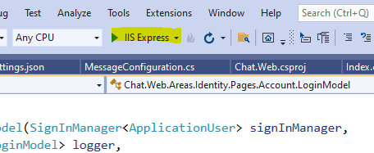

1. You will get a login screen as below

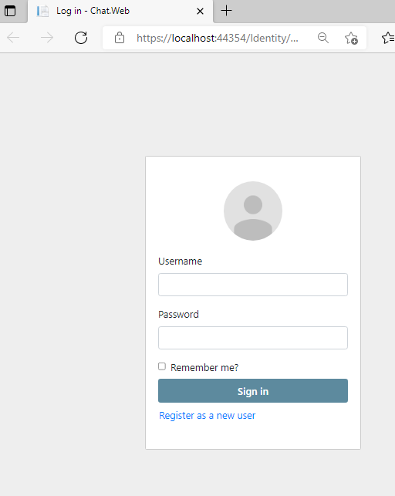

1. Please enter any values on username and password and click on sign in button

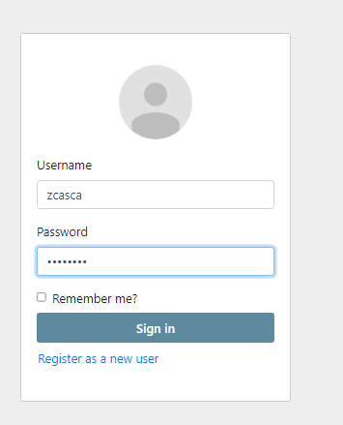

1. It will redirect to database migration screen as below

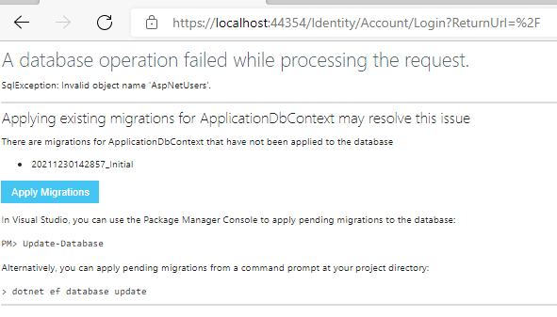

1. Click Apply Migrations, below screen will be shown and refresh the page

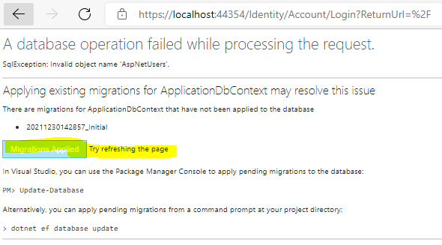

1. Click on Register as new user, enter required details and use the application

